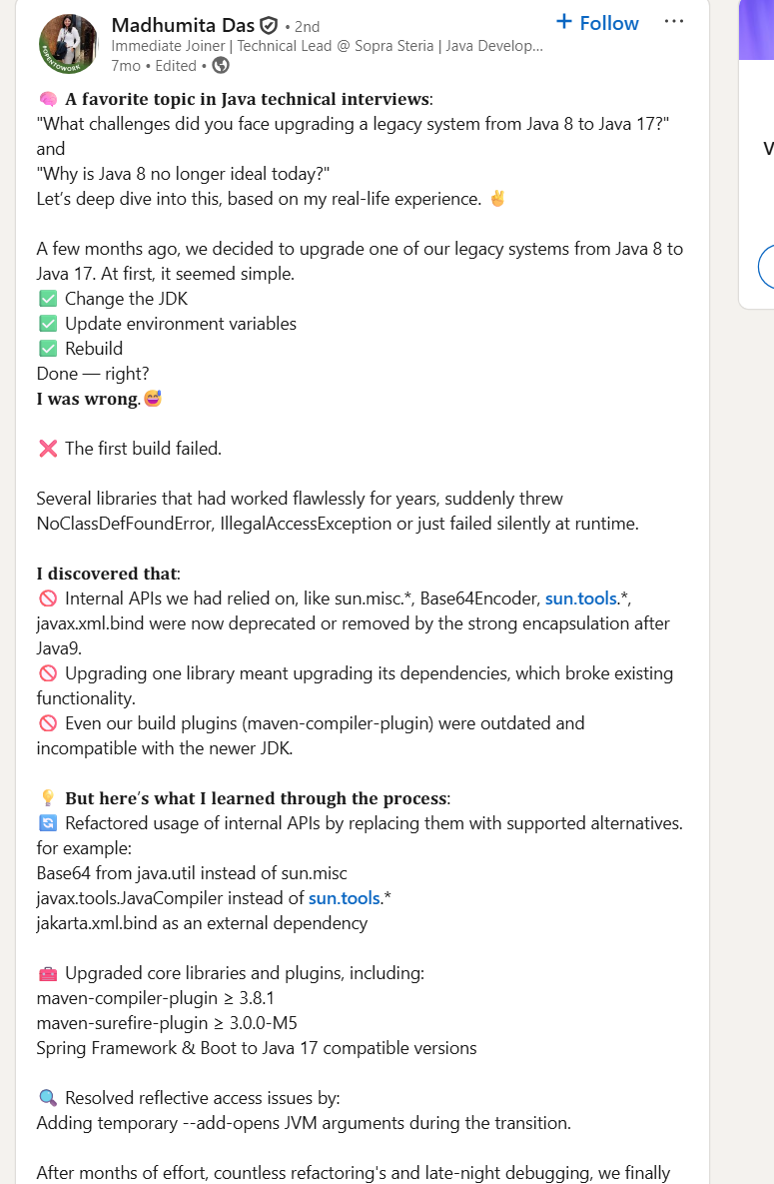

A few months ago, we decided to upgrade one of our legacy systems from Java 8 to Java 17. At first, it seemed simple.
✅ Change the JDK
✅ Update environment variables
✅ Rebuild
Done — right?
𝐈 𝐰𝐚𝐬 𝐰𝐫𝐨𝐧𝐠.😅
❌ The first build failed.
Several libraries that had worked flawlessly for years, suddenly threw NoClassDefFoundError, IllegalAccessException or just failed silently at runtime.
𝐈 𝐝𝐢𝐬𝐜𝐨𝐯𝐞𝐫𝐞𝐝 𝐭𝐡𝐚𝐭:
🚫 Internal APIs we had relied on, like sun.misc.*, Base64Encoder, sun.tools.*, javax.xml.bind were now deprecated or removed by the strong encapsulation after Java9.
🚫 Upgrading one library meant upgrading its dependencies, which broke existing functionality.
🚫 Even our build plugins (maven-compiler-plugin) were outdated and incompatible with the newer JDK.
💡 𝐁𝐮𝐭 𝐡𝐞𝐫𝐞’𝐬 𝐰𝐡𝐚𝐭 𝐈 𝐥𝐞𝐚𝐫𝐧𝐞𝐝 𝐭𝐡𝐫𝐨𝐮𝐠𝐡 𝐭𝐡𝐞 𝐩𝐫𝐨𝐜𝐞𝐬𝐬:
🔄 Refactored usage of internal APIs by replacing them with supported alternatives. for example:
Base64 from java.util instead of sun.misc
javax.tools.JavaCompiler instead of sun.tools.*
jakarta.xml.bind as an external dependency
🧰 Upgraded core libraries and plugins, including:
maven-compiler-plugin ≥ 3.8.1
maven-surefire-plugin ≥ 3.0.0-M5
Spring Framework & Boot to Java 17 compatible versions
🔍 Resolved reflective access issues by:
Adding temporary --add-opens JVM arguments during the transition.
After months of effort, countless refactoring's and late-night debugging, we finally had our system running on 𝐉𝐚𝐯𝐚 𝟏𝟕 — 𝐬𝐭𝐚𝐛𝐥𝐞, 𝐟𝐚𝐬𝐭𝐞𝐫, 𝐚𝐧𝐝 𝐟𝐮𝐭𝐮𝐫𝐞-𝐩𝐫𝐨𝐨𝐟.
This not only helped us stabilize the upgrade, but also helped the groundwork for future migrations (maybe even to Java 21🚀)
🔍 𝐖𝐡𝐲 𝐰𝐞 𝐡𝐚𝐝 𝐭𝐨 𝐥𝐞𝐚𝐯𝐞 𝐉𝐚𝐯𝐚 𝟖 𝐛𝐞𝐡𝐢𝐧𝐝:
While Java 8 introduced about 10years before and it was great for its time — it introduced streams, lambdas, Optional and functional programming. But today?
❌ No modern language features (like record, var, switch expressions, Sealed classes, Sealed interfaces etc.)
❌ It’s just not well supported by newer frameworks (Spring Boot 3, Jakarta EE 10, etc.)
❌ Slower performance and higher memory usage.
❌ And most importantly: End of public updates (unless you're paying for support)
Have you ever upgraded a legacy system and faced unexpected issues? I’d love to hear your story. 🙂

(25) Migrating from JDK 8 to JDK 17 | LinkedIn
Migrating from JDK 8 to JDK 17



Rohit Narwani

Software Chapter Lead at UBS, Ex-Citibank, Ex-Zycus
June 29, 2025
Considering upgrading your Java applications from JDK 8 to the latest Long-Term Support (LTS) release, JDK 17? Then this article is designed to guide you through the essential changes and challenges you might encounter. While the specific impact can vary significantly depending on your application's architecture and dependencies, this article covers the most common migration hurdles to ensure a smoother transition
Date and Time Parsing
If your application formatted dates as "Sep" using an older JDK, and you're now parsing these dates with JDK 17 and Locale.UK, it will throw a DateTimeParseException. This is because, in JDK 17, the expected abbreviation for September in Locale.UK (en_GB locale) is now 'Sept' instead of 'Sep'. This change reflects stricter adherence to locale-specific standards or internal parsing logic updates in newer JDKs. For more details, refer to. September's short form "Sep" no longer parses in Java 17 in en_GB locale
Module System Changes (and the "Split Package" Problem):
The Java Platform Module System (JPMS), introduced in JDK 9, continues to evolve. While you might not need to fully modularize your application, understanding how modules interact and how the classpath has evolved is crucial. Pay attention to warnings or errors related to "unnamed modules" or "split packages."
A common and significant issue you might face is the "split package" problem, especially with org.w3c.dom. In Java 9 and higher, a package name must not be accessible from more than one module. Everything on the classpath is considered part of the <unnamed> module. Since the org.w3c.dom package is already used by the Java system library (in the java.xml module), your application code and any dependencies/JARs must not include this package, even if you are not explicitly using JPMS (i.e., without a module-info.java file).
If you encounter errors like "package org.w3c.dom is accessible from more than one module," it means you have conflicting JARs on your classpath that bundle the org.w3c.dom package. To resolve this, you must identify and remove the external JARs that unnecessarily include org.w3c.dom. Typical conflicting JARs to check for include:
- xml-apis.jar
- xercesImpl.jar
- xalan.jar
Carefully review your project's dependencies and remove any that are redundant or cause this package duplication. Often, these older JARs were necessary in JDK 8 environments but are now provided by the JDK itself.
Package Name Changes (Jakarta EE Transition)
The Jakarta EE transition refers to the shift from Java EE (Java Enterprise Edition) to Jakarta EE under the stewardship of the Eclipse Foundation. One of the major impacts of this transition is the change in package names for the enterprise APIs from javax.* to jakarta.*. Oracle retained the trademark on the javax.* package. As part of donating Java EE to the Eclipse Foundation, the new specification had to adopt a new namespace. Hence, Jakarta EE 9+ started using jakarta.*.
- javax.* to jakarta.*: A significant change stemming from the move to Jakarta EE is the package renaming from javax.* to jakarta.* for many Java EE APIs (e.g., Servlet, JPA, JAXB, JAX-WS). You'll need to update your imports and dependencies accordingly. For example, javax.servlet.http.HttpServlet becomes jakarta.servlet.http.HttpServlet.
- JSTL Migration: JavaServer Pages Standard Tag Library (JSTL) packages have also moved to the jakarta.servlet.jsp.jstl namespace.
- JavaMail Migration: The JavaMail API has also transitioned to Jakarta Mail, requiring updates to your imports (e.g., javax.mail to jakarta.mail).
JDBC Driver Updates
Ensure your JDBC drivers are compatible with JDK 17. Older drivers might not work correctly or might not take advantage of performance improvements. Check the database vendor's documentation for the latest recommended driver versions. For example, for Oracle databases, ensure you're using ojdbc11.jar or ojdbc17.jar.
Deprecations and Removals
- JDK 17 has stricter access controls for reflection. Check for sun.package usage*: These internal APIs are heavily restricted or removed
- sun.misc.BASE64Encoder / BASE64Decoder: These internal APIs were deprecated in JDK 9 and removed from JDK11. You must replace them with java.util.Base64 for encoding and decoding operations. This is a critical change for many legacy applications.
Before(JDK8):

import sun.misc.BASE64Encoder;
import sun.misc.BASE64Decoder;

BASE64Encoder encoder = new BASE64Encoder();
String encoded = encoder.encode(data);

BASE64Decoder decoder = new BASE64Decoder();
byte[] decoded = decoder.decodeBuffer(encoded);

After (JDK 17):

import java.util.Base64;

String encoded = Base64.getEncoder().encodeToString(data);
byte[] decoded = Base64.getDecoder().decode(encoded);
- java.xml.bind (JAXB) and java.xml.ws (JAX-WS): These modules are no longer part of the JDK. If your application relies on JAXB or JAX-WS, you'll need to explicitly add them as dependencies (e.g., using Maven or Gradle). Add JAXB as an external dependency.
<dependency>
<groupId>jakarta.xml.bind</groupId>
<artifactId>jakarta.xml.bind-api</artifactId>
<version>4.0.0</version>
</dependency>
<dependency>
<groupId>org.glassfish.jaxb</groupId>
<artifactId>jaxb-runtime</artifactId>
<version>4.0.3</version>
</dependency>
- jdk.nashorn.internal.ir.ObjectSizeCalculator: This internal API was removed in JDK 15. If you were using it for object size calculations, you can use Java Object Layout(JOL) or you can write your own code to calculate object size. Using JOL:
<dependency>
<groupId>org.openjdk.jol</groupId>
<artifactId>jol-core</artifactId>
<version>0.17</version>
</dependency>
- Applet API and RMI Activation are also removed in JDK17. The Security Manager is deprecated in JDK 17 and will be removed in future versions.
Framework Migration (Spring, Hibernate, etc.)
If you're using frameworks like Spring, Hibernate, or others, ensure you are on versions that officially support JDK 17. Older versions might not be compatible with the new JDK or the Jakarta EE package changes. For instance, Spring Framework 5.3+ and Spring Boot 2.5+ are good starting points for JDK 17 compatibility.
Tooling and Build System Updates
Ensure your build tools (Maven, Gradle), IDEs (IntelliJ IDEA, Eclipse), and CI/CD pipelines are updated to versions that fully support JDK 17. This will prevent build failures and ensure proper compilation and execution.
Update Maven Compiler Plugin:
<plugin>
<groupId>org.apache.maven.plugins</groupId>
<artifactId>maven-compiler-plugin</artifactId>
<version>3.11.0</version>
<configuration>
<source>17</source>
<target>17</target>
<release>17</release>
</configuration>
</plugin>
Automating Migration with OpenRewrite
OpenRewrite is an automated code refactoring tool that simplifies migration from Java 8 to newer versions like Java 17. It provides ready-to-use recipes for upgrading JDK versions, library dependencies, and code patterns.
- Setup OpenRewrite in your Project. Add the OpenRewrite Plugin to your pom.xml. If you have multi-module structure, add the plugin to the parent pom.xml.
<plugin>
<groupId>org.openrewrite.maven</groupId>
<artifactId>rewrite-maven-plugin</artifactId>
<version>5.11.1</version>
<configuration>
<activeRecipes>
<recipe>org.openrewrite.java.migrate.UpgradeToJava17</recipe>
</activeRecipes>
</configuration>
<!-- Add Java recipe-->
<dependencies>
<dependency>
<groupId>org.openrewrite.recipe</groupId>
<artifactId>rewrite-migrate-java</artifactId>
<version>2.9.0</version>
</dependency>
</dependencies>
</plugin>
- Run the following command to apply the recipe. If you have multi module project, run the below command at all the child pom.xml.
mvn rewrite:run
JDK 17 brings modern language features, performance gains, and long-term support. While the migration may seem complex, using structured tools and recipes like OpenRewrite can make the transition smooth and less error-prone.

